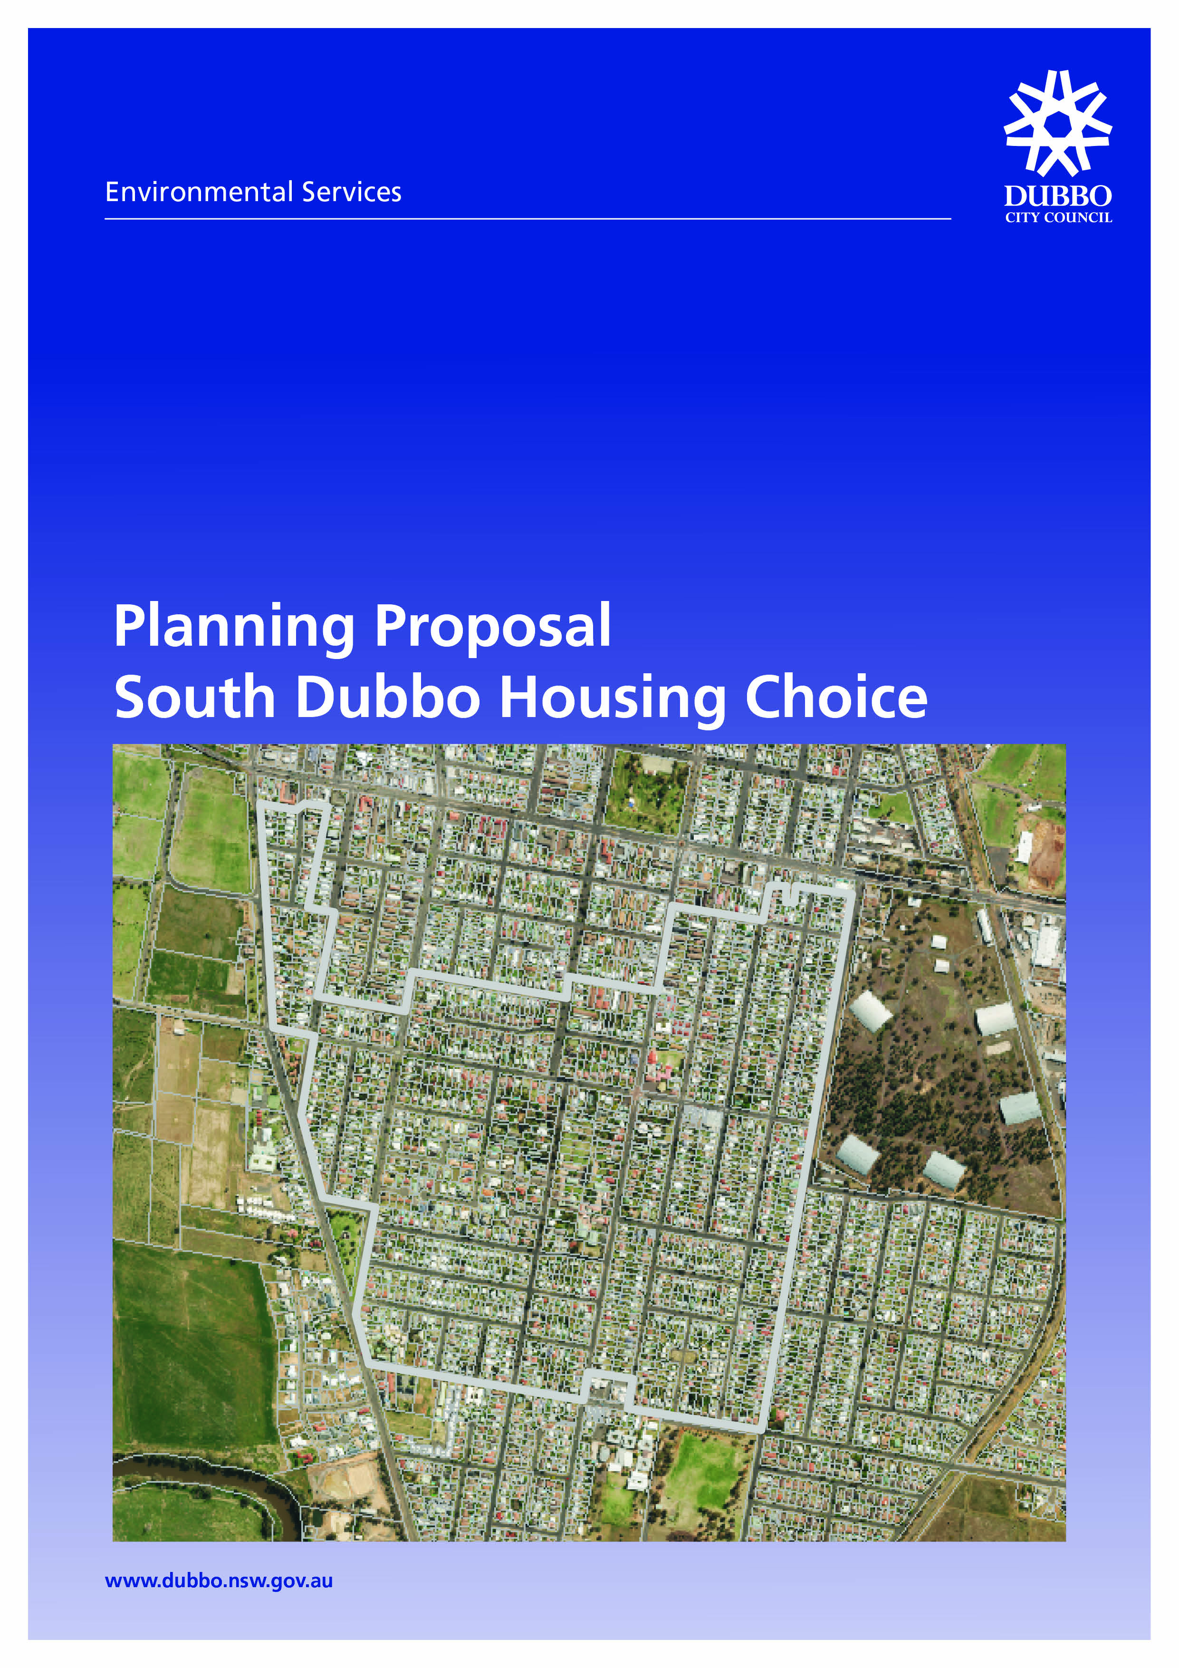

**TABLE OF CONTENTS**

**Executive Summary**

**Part 1** Objectives or intended outcomes

**Part 2** Explanation of provisions

**Part 3** Justification

**A** Need for the Planning Proposal

**B** Relationship to strategic planning framework

**C** Environmental, social and economic impact

**D** State and Commonwealth interests

**Part 4** Mapping

**Part 5** Community consultation

**Part 6** Project timeline

**Appendices**

1. Council reports and Council resolutions.

2. Submissions provided to Council by the Real Estate Institute NSW (Orana Division).

3. Land zoning maps.

4. Lot size maps.

5. Review of Dubbo Residential Areas Development Strategy by consultants Hill PDA.

6. List of heritage items.

7. Project timeline.

**Executive Summary**

A Planning Proposal has been prepared to facilitate the rezoning of an area of land in South Dubbo from R2 Low Density Residential to R1 General Residential under the provisions of the Dubbo Local Environmental Plan 2011.

The Planning Proposal has been prepared in accordance with Section 55 of the Environmental Planning and Assessment Act, 1979 and the NSW Government Department of Planning and Infrastructure ‘A Guide to preparing planning proposals.’

The Planning Proposal has been supported by Council as a component of a range of Council initiatives to increase the availability of land in the City for further residential development opportunities and in particular ensure the City has access to a range of housing types and styles to support a number of price points in the Dubbo Housing Market. A copy of the Council reports and Council resolutions are included in **Appendix 1**.

The Planning Proposal is consistent with the provisions of the Dubbo Urban Areas Development Strategy 1996 and the Review of the Strategy undertaken in 2007. The Planning Proposal is also consistent with the recommendations of a new Residential Areas Development Review undertaken by Council in 2013.

The area subject of the Planning Proposal is an established residential area within close proximity to commercial premises, community facilities and employment opportunities.

**Part 1 Objectives or Intended Outcomes**

The objective of the Planning Proposal is to facilitate the rezoning of land in South Dubbo to allow for further residential development opportunities afforded by zoning the land R1 General Residential in place of the current zoning of the land as R2 Low Density Residential under the provisions of the Dubbo Local Environmental Plan 2011.

The Real Estate Institute of NSW (Orana Division) (Orana REI) has provided Council with a number of submissions in respect to the availability of opportunities in the City for residential development including opportunities for residential infill and medium density development. The submissions provided by the Orana REI are included in **Appendix 2**.

The proposed rezoning included in the Planning Proposal is a component of a range of Council initiatives to increase the availability of land in the City for further residential development opportunities and to in particular ensure the City has access to a range of housing types and styles to support a number of price points in the Dubbo Housing Market.

**Part 2 Explanation of Provisions**

The Planning Proposal seeks to amend the Dubbo Local Environmental Plan 2011 by undertaking the following amendments to the area shown on Map 1 provided on the following page:

* Amending the Dubbo Local Environmental Plan 2011 Land Zoning Map – Sheet LZN_008A in relation to the subject area of South Dubbo from R2 Low Density Residential to R1 General Residential.
* Amending the Dubbo Local Environmental Plan 2011 Land Zoning Map – Sheet LZN_008B in relation to the subject area of South Dubbo from R2 Low Density Residential to R1 Low Density Residential.
* Amending the Dubbo Local Environmental Plan 2011 Lot Size Map – Sheet LSZ_008A in relation to the subject area of South Dubbo from M 600 square metres to D 300 square metres.
* Amending the Dubbo Local Environmental Plan 2011 Lot Size Map – Sheet LSZ_008B in relation to the subject area of South Dubbo from M 600 square metres to D 300 square metres.

A copy of the draft Land Zoning Maps included the changes proposed are included in **Appendix 3**. A copy of the draft Lot Size Maps including the changes proposed are included in **Appendix 4**.

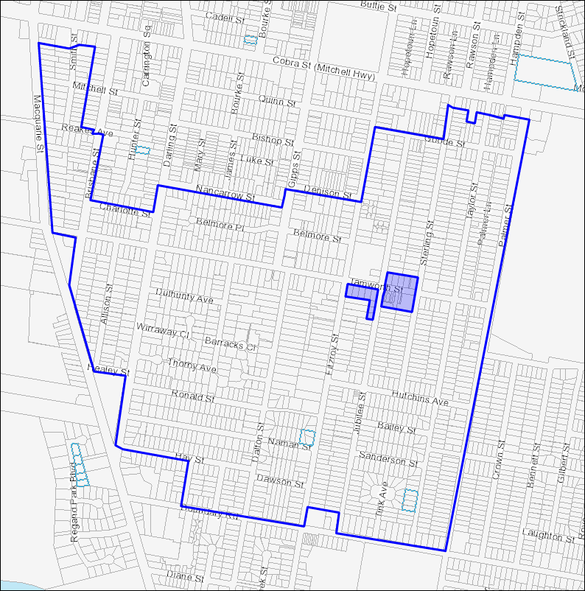

**MAP 1 Subject Area to be zoned R1 General Residential ResidentialResidential**

**Legend**

Blue outline with no fill = area of South Dubbo subject to the Planning Proposal.

Blue outline with blue shading = area of South Dubbo not subject to the Planning Proposal.

**Part 3 Justification**

**A. Need for the Planning Proposal**

**1. Is the Planning Proposal the result of any Strategic Study or report?**

Submissions from the Real Estate Institute of NSW (Orana Division)

In consideration of the Dubbo Local Environmental Plan 2011, Council has received a number of submissions from the Real Estate Institute of NSW (Orana Division) (Orana REI) in respect to the availability of land and opportunities in the City for further residential development.

The submissions from the Orana REI have sought land for further residential development within close proximity to commercial activities, community facilities and employment opportunities to facilitate a range of opportunities including multi dwelling housing. South Dubbo was chosen as an appropriate area to pursue further residential development opportunities given the close proximity to the range of activities above, the size and shape of allotments in the area and the synergies South Dubbo has with the North Dubbo residential area that was zoned R1 General Residential with gazettal of the Dubbo Local Environmental Plan 2011.

The submissions provide an examination of the current state of the Dubbo Housing Market and provide a level of comparison with other regional cities. The submissions provide information that there has been a long term shortage of supply of residential property to purchase for owner occupiers and investors in Dubbo. In addition, information is also provided that there has been a long term shortage in the availability of rental properties in the City, which is as a result of the shortage of a range of residential property types in the Dubbo Housing Market.

The Dubbo Local Environmental Plan 2011 zoned a smaller area of South Dubbo R1 General Residential. Further extension of the R1 zoning in South Dubbo was not pursued at that time as the current proposal would have required a further public exhibition prior to finalisation of the Dubbo LEP 2011.

Table 1 from the Orana REI submissions, provided on the following page, details the annual percentage change in median weekly rents for Dubbo and other regional cities:

**TABLE 1**

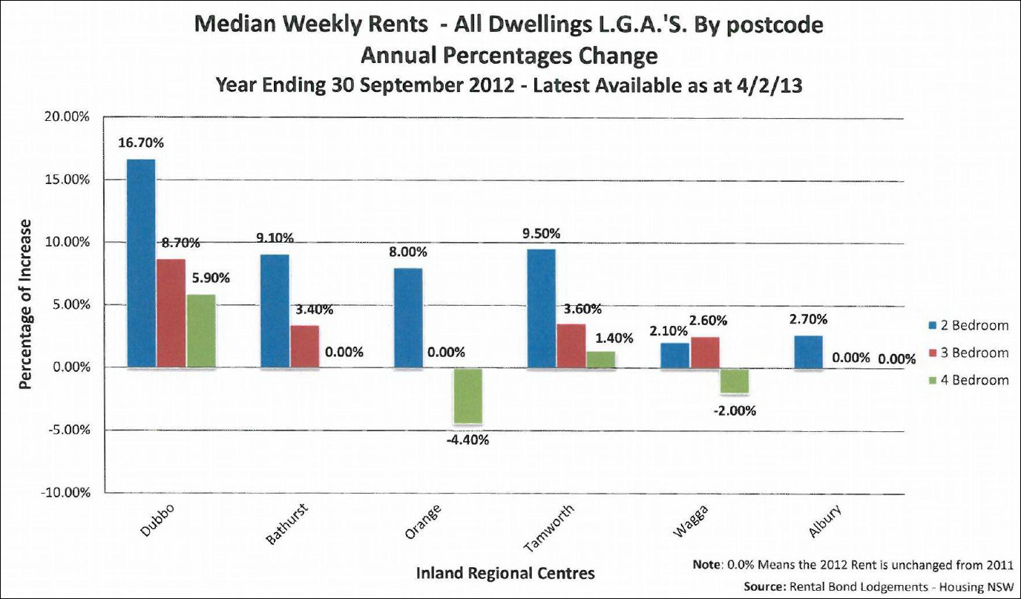

The information shows that the significant rise in the annual percentage change of weekly rents in respect to two (2), three (3) and four (4) bedroom dwellings is the result of the level of availability of residential development opportunities in the City.

The submissions conclude that the availability of land for a range of different housing types including multi dwelling housing has restricted the number of developments undertaken in the City and therefore had the effect of restricting housing supply.

Review of the Supply and Demand for Residential Housing

Council, in undertaking the first Administrative Review of the Dubbo Local Environmental Plan 2011, received a number of submissions in respect to the availability of housing and housing opportunities in the City. Council again received a submission from the Real Estate Institute of NSW (Orana Division) (Orana REI) seeking further lands in South Dubbo to be rezoned from R2 Low Density Residential to R1 General Residential.

In consideration of issues in respect of housing affordability and housing choice in the City, Council engaged the services of consultants Hill PDA to undertake a review of the supply and demand for residential development to assess the state of the Dubbo Housing Market and the success or otherwise of the Dubbo Residential Areas Development Strategy. A copy of the report prepared by consultants Hill PDA is included in **Appendix 5**.

The Hill PDA assessment confirmed that the rental vacancy rate in Dubbo is at an all time low, which reflects the compressed nature of the Dubbo Housing Market and the availability of a range of housing types.

The Hill PDA assessment found that changing demographics and employment trends dictate that housing supply needs to respond to a diversity of needs in the City across a number of different price points, incomes and age groups. It is considered that the Dubbo Housing Market has traditionally provided a level of resistance to smaller lots less than 600 square metres in area. However, it is considered that this situation is changing over time primarily due to affordability and lifestyle reasons.

Hill PDA provided information that outside of the Dubbo Central Business District, people may have a level of resistance to small lot and multiple dwelling housing. It is considered that as a compromise, people are coming to accept that a smaller block would equally suit their lifestyle and budget restraints. It was also considered that housing supply alone is insufficient in promoting housing choice and affordability. The provision of any flexibility in planning controls in Dubbo should be reflective of the goal of supporting further flexibility in housing choice, which could be realised through further flexibility in the Dubbo Housing Market.

As part of the analysis, Hill PDA considered the financial feasibility of a range of notional medium density development schemes in Dubbo to assess their viability in current market conditions. The analysis utilised generic assumptions regarding site acquisition, development costs, fees and charges and indicative development yield based on recent market examples and industry averages. The feasibility assumed a fairly conservative Project Internal Rate of Return (16-18%) in keeping with Hill PDA’s assessment of the prevailing Dubbo market conditions.

The analysis is hypothetical and the viability of individual projects of this type is very dependent on individual site conditions, development design and the risk appetite of the developer. However, as a guide, the feasibility analysis suggests that developments on sites exceeding 2,400 square metres in size are the most likely to be feasible in current market conditions.

Given this analysis, Hill PDA provided information that Council should consider significantly expanding the areas zoned R1 General residential (the R1 General Residential zone permits medium and high density residential development). The report also notes the recent efforts of Council to increase the portion of R1 zoned land available for this type of development, both in North Dubbo and a selected area of South Dubbo. However, given the feasibility analysis, Hill PDA provided information that there limited options are available in Dubbo for sites to accommodate medium density development of a size and scale necessary to meet the assumed investment hurdle rates.

Map 2 provided below shows three (3) separate regimes for the rezoning of land in South Dubbo from R2 Low Density Residential to R1 General Residential.

**MAP 2 Evolution of the Planning Proposal**

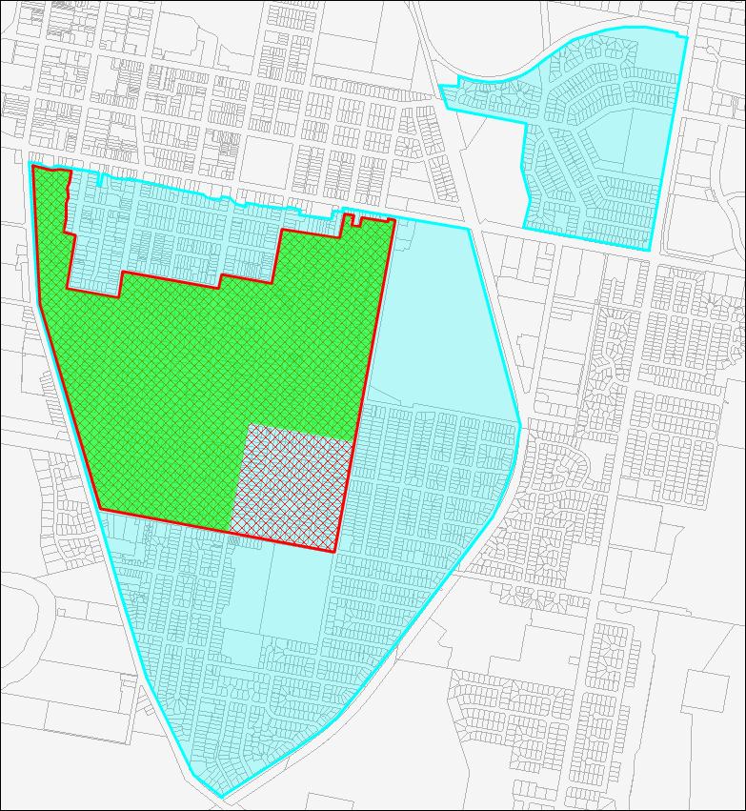

**Light blue area** Proposed Hill PDA R1 General Residential zoned area. **Green area** Real Estate Institute of NSW (Orana Division) proposed R1 General Residential zoned area. **Red hatched area** Area of South Dubbo subject of the Planning Proposal.

As can be seen from map 2 provided on the previous page, the Real Estate Institute of NSW (Orana Division) proposed the area of South Dubbo to be rezoned to R1 General Residential as shown in yellow. The proposal provided by the Orana REI included an area of Smith Street and Tamworth Street, which was recommended to not be pursued by Council officers based on the presence of a number of heritage items and the character of development in the area and the receipt of objections from landowners in this area during exhibition of the Dubbo LEP 2011. Based on these characteristics, an alternative was proposed by Council officers that did not include the Smith Street and Tamworth Street areas, however included an additional area bound by Palmer Street, Boundary Road, Hutchins Avenue and Fitzroy Street, which was not a component of the Orana REI proposal. This area was chosen based on the age and characteristics of development in the area.

Hill PDA proposed an extensive area of South and Central Dubbo (as shown in light blue) to be rezoned to R1 General Residential. It is unclear as to why the extended area was chosen by Hill PDA. The area proposed by Hill PDA does not provide any further significant opportunities for viable development to be undertaken. It is also considered that the area proposed by Hill PDA is inconsistent with the spatial nexus between the R1 General Residential zone and the Dubbo Central Business District, which is a core element of the proposal put forward by the REI, which aims to ensure land is only rezoned within a reasonable proximity to employment, shopping and community facilities.

Council subsequently resolved to pursue a Planning Proposal for the area as shown in red hatching, which included the Smith Street/ Tamworth Street area and the area bound by Palmer Street, Boundary Road, Hutchins Avenue and Fitzroy Street.

**2. Is the Planning Proposal the best means of achieving the objectives or intended outcomes or is there a better way?**

The land subject to the Planning Proposal is currently zoned R2 Low Density Residential under the provisions of the Dubbo LEP 2011. The intended outcome of delivering a greater level of flexibility and choice in the provision of residential development within the subject area cannot currently be delivered under the provisions of LEP 2011.

In respect to residential land use activities, the R2 Low Density Residential zone currently allows for the development of dwelling houses, attached dual occupancies and detached dual occupancies.

It is considered that to provide for a greater level of housing choice and flexibility that the R1 General Residential zone provides a greater number of residential land use alternatives as permissible development that are not permissible under the R2 zone, which include the following:

* Attached dwellings;
* Boarding houses;
* Dwelling houses;
* Group homes;
* Hostels;
* Multi dwelling housing;
* Residential flat buildings;
* Semi-detached dwellings; and
* Seniors housing.

**B. Relationship to Strategic Planning Framework**

**3. Is the Planning Proposal consistent with the objectives and actions of the applicable regional or sub-regional strategy?**

The Dubbo Local Government Area does not have an applicable regional land use strategy.

**4. Is the Planning Proposal consistent with a local strategy or other local strategic plan?**

The Dubbo Urban Areas Development Strategy forms the basis of the land use zonings and planning controls provided in the Dubbo Local Environmental Plan 2011 (LEP 2011). The Dubbo Urban Areas Development Strategy commenced operation in 1996. The Strategy was reviewed by Council in 2007 and again in 2011 with preparation of the Dubbo LEP 2011.

The Department of Planning and Infrastructure, in consideration of the Dubbo LEP 2011 provided Council with the Director General’s endorsement of the Dubbo Urban Areas Development Strategy 1996 and the Review undertaken in 2007.

The Dubbo Urban Areas Development Strategy consists of a number of components as provided below:

* A) Residential Areas Development Strategy;
* B) Commercial Areas Development Strategy;
* C) Industrial Areas Development Strategy;
* D) Institutional Areas Development Strategy;
* E) Recreational Areas Development Strategy; and
* Future Directions and Structure Plan.

The South Dubbo residential area subject of the Planning Proposal is situated within the Central Subdistrict (South Precinct). The Strategy provides the following future objectives for land use in the precinct:

* *Protect and enhance the quality and amenity of the residential environment of the precinct;*
* *Clarify, protect and reinforce the heritage and streetscape values of residential areas by implementing the Freeman Collett Report, and subsequent analyses as recommendations as adopted;*
* *Ensure any redevelopment is compatible with the established character of the neighbourhood;*
* *Allow medium density redevelopment only on sites selected for their particular suitability for such use; and*
* *Facilitate residential development of the 1(d) areas where suitable.*

A review of the Urban Areas Development Strategy was undertaken by Council in 2007. As a component of the Review and as a result of submissions provided by the Real Estate Institute of NSW (Orana Division), Council examined the issue of medium density housing, housing choice and affordability in the City. This included an examination of existing zoned areas and areas within close proximity to commercial activities, recreational facilities and support services.

In consideration of the availability of land for the purposes of medium density housing, the Review provided the following information:

*“In summary the submission of the Real Estate Institute of NSW (Orana Division) recommends a broad investigation to promote means of encouraging medium density housing in suitable locations. The submission provides significant data to support the recommendation. It is considered that areas of north Dubbo, Central Dubbo and to a lesser extent south Dubbo could be suitable for medium density housing. The submission emphasises that quality design is an important attribute to successfully implement this type of housing.”*

Further, the Review provided the following recommendations:

*“(i) Opportunities for Medium Density Housing in the Inner City*

*It is recommended that inner city sites adjacent to commercial sites, key services and recreational facilities be identified for future rezoning to medium density to encourage greater diversity and a mix of built form in these key locations to cater for a diversified population and more liveable communities within close proximity to the CBD.*

*(ii) Medium Density Zoned Land*

*It is further recommended that future urban release areas incorporate medium density developments adjacent to public spaces, community facilities or focal nodes within the development.”*

Comment:

The proposed rezoning is considered to be not inconsistent with the Dubbo Urban Areas Development Strategy 1996 and the Review of the Dubbo Urban Areas Development Strategy undertaken in 2007.

The proposed rezoning of land in South Dubbo to R1 General Residential will provide a greater level of flexibility and choice in the delivery of residential development outcomes within a reasonable proximity of the Dubbo Central Business District, community services and areas of public open space.

**5. Is the Planning Proposal consistent with applicable State Environmental Planning Policies?**

The following table provides consideration of the applicable State Environmental Planning Policies for consideration in the planning proposal:

|  |  |  |
| --- | --- | --- |
| **State Environmental Planning Policy** | **Relevance** | **Discussion** |
| State Environmental Planning Policy (Infrastructure) 2007 | Provides a consistent approach for infrastructure and the provision of services across NSW, and to support greater efficiency in the location of infrastructure and service facilities. | Nothing in this Planning Proposal impacts upon the aims and provisions of this SEPP. |
| State Environmental Planning Proposal No. 6 – Number of Storeys in a Building | The SEPP guides the understanding and calculation across Environmental Planning Instruments in respect to the number of storeys in a building. | Nothing in the Planning Proposal impacts upon the aims and provisions of this SEPP. |
| State Environmental Planning Policy No 32 – Urban Consolidation (Redevelopment of Urban Land) | The SEPP guides urban consolidation of land for the development of multiple dwelling housing of a regional significance. | Nothing in the Planning Proposal impacts upon the aims and provisions of this SEPP. |
| State Environmental Planning Policy No 65 – Design Quality of Residential Flat Development | The SEPP guides the development of Residential Flat Buildings and sets design quality standards. | The Planning Proposal will provide additional land to be zoned R1 General Residential, which will allow for the development of residential flat buildings.  Nothing in this Planning Proposal impacts upon the aims and objectives of this SEPP. |
| State Environmental Planning Policy (Affordable Rental Housing) 2009 | The SEPP provides guidance in the provision and composition of affordable rental housing. | The Planning Proposal will provide a range of residential development opportunities including opportunities for the provision of affordable rental housing.  Nothing in this Planning Proposal impacts upon the aims and objectives of this SEPP. |
| State Environmental Planning Policy (Exempt and Complying Development Codes) 2008 | The SEPP guides the provision of Exempt and Complying development across the State. | Nothing in the Planning Proposal impacts upon the aims and provisions of this SEPP. |
| State Environmental Planning Policy (Housing for Seniors or People with a Disability) 2004 | The SEPP guides the provision of housing for seniors or for persons with a disability. The Policy is applicable to residential lands. | Nothing in the Planning Proposal impacts upon the aims and provisions of this SEPP. |
| State Environmental Planning Policy No. 55 – Remediation of Land | The SEPP guides the consideration of the development of potentially contaminated lands. | It is considered that the subject area may contain a small number of sites, which could be potentially contaminated lands.  Consideration of the contamination status of the subject lands is a requirement of the development assessment process.  Nothing in this Planning Proposal impacts upon the aims and objectives of this SEPP. |

**6. Is the Planning Proposal consistent with any applicable 117 Directions?**

The following table provides consideration of the applicable Section 117 Directions for consideration in the planning proposal:

|  |  |  |
| --- | --- | --- |
| **Section 117 Direction** | **Relevance** | **Discussion** |
| 1.3  Mining, Petroleum Production and Extractive Industries | The Direction aims to ensure that the future extraction of State or regionally significant reserves of coal, other minerals, petroleum and extractive industries are not compromised by inappropriate development. | There are no known coal or petroleum reserves in the area. There are no extractive industries in operation.  The Planning Proposal is consistent with this Direction as the proposal will not prohibit mining or impact the availability of extractive resources. |
| 2.3  Heritage Conservation | The Direction aims to ensure the conservation of items, areas, objects and places of environmental heritage significance and indigenous heritage significance. | The Planning Proposal is consistent with the Direction.  The Direction requires a Planning Proposal to contain provisions that facilitate the conservation of:   1. Items, places, buildings, works, relics, moveable objects or precincts of environmental heritage significance to an area, in relation to the historical, scientific, cultural, social, archaeological, architectural, natural or aesthetic value of the item, area, object or place, identified in a study of the environmental heritage of the area, 2. Aboriginal objects or Aboriginal places that are protected under the National Parks and Wildlife Act, 1974, and 3. Aboriginal areas, Aboriginal objects, Aboriginal places or landscapes identified by an Aboriginal heritage survey prepared by or on behalf of an Aboriginal Land Council, Aboriginal body or public authority and provided to the relevant planning authority, which identifies the area, object, place or landscape as being of heritage significance to Aboriginal culture and people.   The area subject to the Planning Proposal contains a number of heritage listed in Schedule 3 of the Dubbo Local Environmental Plan 2011. However, it should be noted that the Planning Proposal will not directly impact the heritage significance of the heritage items.  The Dubbo LEP 2011 contains Clause 5.10 Heritage Conservation, which guides the development and conservation of heritage items in the Dubbo Local Government Area. It is considered that the planning proposal is consistent with this Direction as the proposal does not directly impact the integrity of existing heritage items and the Dubbo LEP 2011 contains heritage conservation provisions. |
| 3.1  Residential Zones | The Direction aims to encourage a variety and choice of housing types to provide for existing and future housing needs, to make efficient use of existing infrastructure and to minimise the impacts of residential development.  The Direction applies where a planning proposal impacts an existing or proposed residential zone. | The Planning Proposal is consistent with the Direction.  In respect of the Planning Proposal, the Direction requires the following:  (4) A Planning Proposal must include provisions that encourage the provision of housing that will:  (a) broaden the choice of building types and locations available in the housing market, and  (b) make more efficient use of existing infrastructure and services, and  (c) reduce the consumption of land for housing and associated urban development on the urban fringe, and  (d) be of good urban design.  (5) A Planning Proposal must, in relation to land to which this Direction applies:  (a) contain a requirement that residential development is not permitted until land is adequately serviced (or arrangements satisfactory to the council, or other appropriate authority, have been made to service it), and  (b) not contain provisions which will reduce the permissible residential density of land.  The Planning Proposal will provide for the rezoning of existing residential land zoned R2 Low Density Residential to R1 General Residential. The R1 zone will permit a variety of residential development types that will add to the range of permissible residential development types in the subject area. The subject area is classified as an urban infill area within close proximity to existing community facilities, transport and other support networks. |
| 3.3  Home Occupations | This Direction encourages the carrying out of low impact small businesses in dwelling houses. | The Planning Proposal is consistent with the Direction.  The Direction requires planning proposals to permit home occupations to be carried out in dwelling houses without the need for development consent.  The Planning Proposal will not alter the current controls contained in State Environmental Planning Policy (Exempt and Complying Development Codes) 2008 and the Dubbo Local Environmental Plan 2011, which permit the undertaking of home occupations without development consent. |
| 3.4  Integrating Land Use and Transport | This Direction aims to ensure urban development is located in such a manner as to ensure development is designed to facilitate orderly and efficient transport linkages and to ensure development is located within a reasonable proximity to urban development. | The Planning Proposal is consistent with the Direction.  The Direction requires a Planning Proposal to locate zones for urban purposes and include provisions that give effect to and are consistent with the aims, objectives and principles of:   1. Improving Transport Choice – Guidelines for planning and development (DUAP 2001), and 2. The Right Place for Business and Services – Planning Policy (DUAP 2001).   The Planning Proposal is consistent with this Direction and will result in the rezoning of land currently zoned R2 Low Density Residential to R1 General Residential, which is currently predominately developed for low density residential purposes. |
| 4.3  Flood Prone Land | This Direction aims to ensure that development of flood prone land is consistent with the NSW Government’s Flood Prone Land Policy and the principles of the Floodplain Development Manual 2005 | The Planning Proposal is consistent with the Direction.  The Direction requires a Planning Proposal to be consistent with the following:   1. A Planning Proposal must include provisions that give effect to and are consistent with the NSW Flood Prone Land Policy and the principles of the *Floodplain Development Manual 2005* (including the *Guideline on Development Controls on Low Flood Risk Areas*). 2. A Planning Proposal must not rezone land within the flood planning areas from Special Use, Special Purpose, Recreation, Rural or Environmental Protection Zones to a Residential, Business, Industrial, Special Use or Special Purpose Zone. 3. A Planning Proposal must not contain provisions that apply to the flood planning areas which:    1. permit development in floodway areas,    2. permit development that will result in significant flood impacts to other properties,    3. permit a significant increase in the development of that land,    4. are likely to result in a substantially increased requirement for government spending on flood mitigation measures, infrastructure or services, or    5. permit development to be carried out without development consent except for the purposes of agriculture (not including dams, drainage canals, levees, buildings or structures in floodways or high hazard areas), roads or exempt development. 4. A Planning Proposal must not impose flood related development controls above the residential flood planning level for residential development on land, unless a relevant planning authority provides adequate justification for those controls to the satisfaction of the Director-General (or an officer of the Department nominated by the Director-General). 5. For the purposes of a Planning Proposal, a relevant planning authority must not determine a flood planning level that is inconsistent with the Floodplain Development Manual 2005 (including the *Guideline on Development Controls on Low Flood Risk Areas*) unless a relevant planning authority provides adequate justification for the proposed departure from that Manual to the satisfaction of the Director-General (or an officer of the Department nominated by the Director-General).   The Planning Proposal is consistent with the Direction. The Planning Proposal is for a total area of 6,783 square metres within the Flood Planning Area to be rezoned to R1 General Residential. This area of the City is currently mapped as being within the Flood Planning Area and in addition, development currently undertaken in this area and/ or undertaken post rezoning will continue to be subject to the requirements of Clause 7.1 Flood Planning of the Dubbo Local Environmental Plan 2011.  The Planning Proposal is consistent with the remaining requirements of the Direction. |
| 6.1  Approval and Referral Requirements | This Direction aims to ensure Planning Proposals provide LEP provisions that encourage the efficient and appropriate assessment of development. | The Planning Proposal is consistent with the Direction.  The Direction requires a Planning Proposal to not contain provisions that concurrence, consultation or referral to a Minister or public authority |

**C Environmental, social and economic impact**

**7. Is there any likelihood that critical habitat or threatened species, populations or ecological communities or their habitats will be adversely affected?**

It is considered that there is no likelihood that critical habitat or threatened species, populations or ecological communities or their habitats will be adversely affected by the Planning Proposal.

The area subject of the Planning Proposal is classified as an urban area, which at the present time has been substantially developed with the provision of dwelling houses, dual occupancy development and a number of residential flat developments.

The area subject of the Planning Proposal contains numerous mature street trees. However, Council has the care and control of this vegetation type and will not be impacted by any additional residential development.

The area contains a small number of vacant sites with limited vegetation and resultant habitat value. The flora and fauna values of any land will be further considered by Council during the development assessment process for any development on the land.

**8. Are there any environmental impacts and how will they be mitigated?**

Flooding

Approximately 6,873 square metres of the land is situated in the Flood Planning Area under the provisions of the Dubbo Local Environmental Plan 2011. The land situated in the Flood Planning Area is currently zoned R2 Low Density Residential and is used for the purposes of residential development. A map showing the section of the land situated within the Flood Planning Area is provided in Map No. 2.

The Dubbo Floodplain Management Plan and the Dubbo Development Control Plan 2012 require any residential development undertaken on land within the Flood Planning Area to have a minimum floor level 500mm above the level of the 1 in 100 year flood event. Compliance with this requirement is a matter for consideration in the assessment of any development application on the land.

Contamination

Council’s register of potentially contaminated land shows 20 properties within the subject area as being potentially contaminated land.

Given the large area of the proposed rezoning, the nature of development in the area and the likely take-up of the permissible development in the R1 General Residential zone, it is considered appropriate for any direct issues in relation to site contamination to be considered as a component of the development assessment process.

**9. Has the Planning Proposal adequately addressed any social and economic impact?**

Heritage

The subject area contains a number of heritage items listed in the Dubbo Local Environmental Plan 2011. Map 2 provided below shows the number and extent of heritage items situated within the subject area. A list of the applicable heritage items is included in **Appendix 6**.

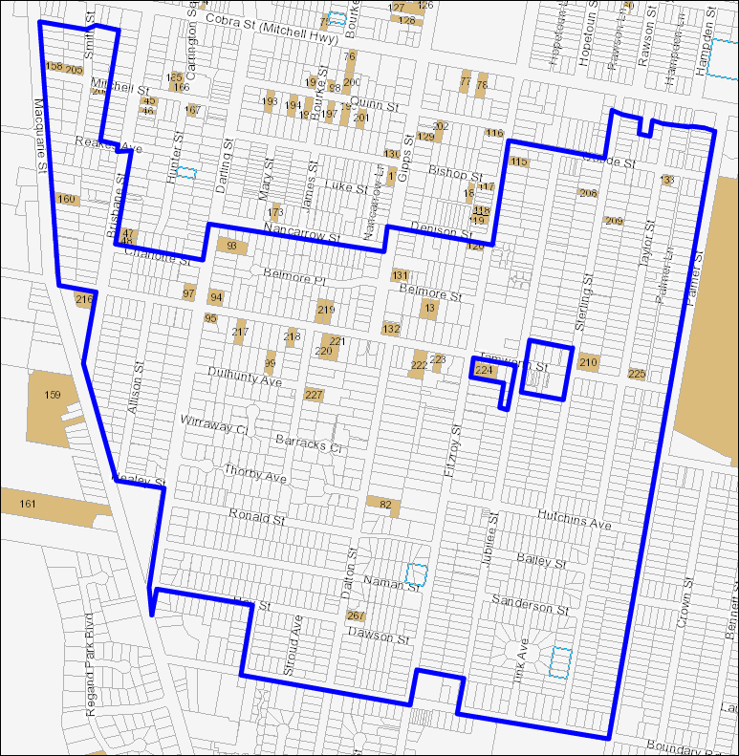

The heritage items located within the subject area are classified as being of local significance. Any development undertaken within the area will be subject to the requirements of Clause 5.10 of the Dubbo Local Environmental Plan 2011. Clause 5.10 of the Dubbo LEP 2011 states as follows:

***“(5) Heritage assessment***

*The consent authority may, before granting consent to any development:*

*(a) on land on which a heritage item is located, or*

*(b) on land that is within a heritage conservation area, or*

*(c) on land that is within the vicinity of land referred to in paragraph (a) or (b),*

*Require a heritage management document to be prepared that assesses the extent to which the carrying out of the proposed development would affect the heritage significance of the heritage item or conservation area concerned.”*

This Planning Proposal is not seeking to alter this requirement. Any development application lodged with Council in the subject area that is on land to which a heritage items is located or in the vicinity of a heritage item, may be required to prepare a heritage management document depending on the impact of the development.

Compliance with Clause 5.10 will be considered by Council as a component of the development assessment process.

Economic Impacts

It is considered that the Planning Proposal will not provide any negative impacts to the locality. The Planning Proposal will provide for the rezoning of a large area of South Dubbo to allow for further residential development opportunities, which will result in additional residents living within a reasonable proximity to commercial activity, community facilities and employment opportunities.

Social Impacts

It is considered that the Planning Proposal will not provide any significant adverse social impacts in the locality.

It is acknowledged that the Planning Proposal will allow for a greater range of residential development types to be undertaken within the subject area, which may provide potential site specific issues.

Any development undertaken within the subject area will be required to comply with the provisions of Council’s Development Control Plan 2012, which specifically guides the design of residential development and its relationship with neighbouring development.

**D State and Commonwealth interests**

**10. Is there adequate public infrastructure for the Planning Proposal?**

Land within the area is connected to reticulated sewerage services, water services, Council’s stormwater network and road infrastructure. In addition, the area is serviced by a regular public bus system that links residents with the Dubbo Central Business and other areas in the City.

Council also has a number of Section 64 and Section 94 Contributions Plans that will apply to any residential development undertaken in the area as provided below:

* Dubbo City Council Water and Sewerage Contribution Policy (Section 64 Contributions Plan);
* Dubbo Section 94 Contributions Plan Open Space and Recreational Facilities;
* Section 94 Contributions Plan Urban Stormwater Drainage Headworks Contributions; and
* Dubbo City Council Section 94 Contributions Plan Roads, Traffic Management and Vehicle Parking.

Each of the Contributions Plans provided above collects contributions from development within the area towards the provision of various infrastructure facilities and the provision and embellishment of public open space.

Council’s Technical Services Division has undertaken assessment of the Planning Proposal and provided information that based on the character of development in the area and the likely take-up of development opportunities presented by the R1 General Residential zoning, that any additional infrastructure will not be immediately required as a result of the Planning Proposal.

It is anticipated that the Planning Proposal will not result in a dramatic increase in development density in the subject area in the short or medium term. It is also anticipated that the rezoning will not result in the provision of large medium density developments based on the size of allotments in the area.

Any upgrade to existing infrastructure including roads will be undertaken by Council when required. It is anticipated that such upgrading would focus on areas of major activity in the subject area (including commercial areas or around schools or the like) or any other areas where problems are identified. It should also be noted that any development proposal within the subject area would be required to provide any necessary infrastructure upgrading following development assessment procedures.

**11. What are the views of State and Commonwealth public authorities consulted in accordance with the Gateway Determination?**

At the present time Council has not undertaken any consultation with any State or Commonwealth public authorities in respect to the Planning Proposal.

Council will undertake consultation with any public authorities as required by the Gateway Determination.

**Part 4 Mapping**

Council has prepared the following draft maps to support the Planning Proposal:

* Draft Dubbo Local Environmental Plan 2011 (Amendment No. 3), Location Map
* Draft Dubbo Local Environmental Plan 2011 (Amendment No. 3), Land Zoning Map – Sheet LZN_008A
* Draft Dubbo Local Environmental Plan 2011 (Amendment No. 3), Land Zoning Map – Sheet LZN_008B
* Draft Dubbo Local Environmental Plan 2011 (Amendment No. 3), Lot Size Map – Sheet LSZ_008A
* Draft Dubbo Local Environmental Plan 2011 (Amendment No. 3), Lot Size Map – Sheet LSZ_008B

**Part 5 Community Consultation**

Council will place the Planning Proposal on public exhibition for a period of not less than 28 days and undertake targeted consultation with residents situated in the subject area. If a Gateway Determination is received prior to the Christmas period, the Planning Proposal will be placed on public exhibition for an extended period of time taking into account this period.

All public consultation processes will be undertaken in accordance with the requirements of the Gateway Determination and the Dubbo City Council Community Engagement Strategy.

**Part 6 Project Timeline**

A copy of the project timeline is included in **Appendix 7**.

.